2. JUnit_Advanced Testing Exercises
Dhruv Diguvapalli
diguvapallidhruv@gmail.com
Exercise 1: Parameterized Tests
EvenChecker.java
package org.example;
public class EvenChecker {
public boolean isEven(int number) {
return number % 2 == 0;
}
}
EvenCheckerTest.java
package org.example;
import org.junit.jupiter.params.ParameterizedTest;
import org.junit.jupiter.params.provider.ValueSource;
import static org.junit.jupiter.api.Assertions.*;
public class EvenCheckerTest {
private final EvenChecker checker = new EvenChecker();
@ParameterizedTest
@ValueSource(ints = {2, 4, 6, 8, 10})
void testEvenNumbers(int number) {
assertTrue(checker.isEven(number));
}
@ParameterizedTest
@ValueSource(ints = {1, 3, 5, 7, 9})
void testOddNumbers(int number) {
assertFalse(checker.isEven(number));
}
}
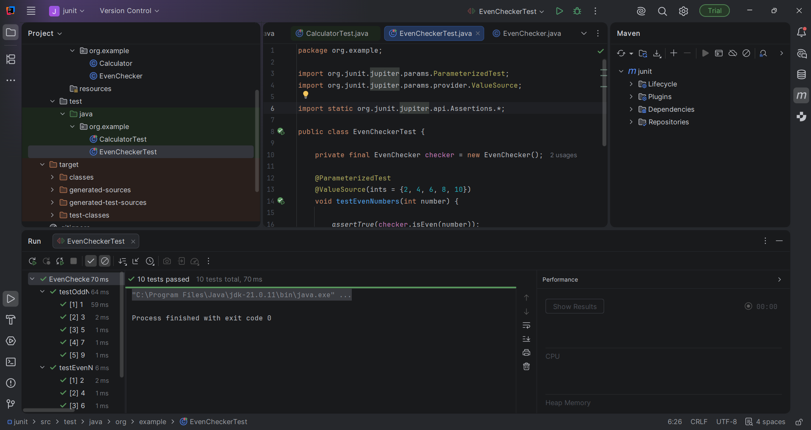

Exercise 2: Test Suites and Categories
AllTests.java
package org.example;
import org.junit.platform.suite.api.SelectClasses;
import org.junit.platform.suite.api.Suite;
@Suite
@SelectClasses({
EvenCheckerTest.class,
ExceptionThrowerTest.class,
PerformanceTesterTest.class
})
public class AllTests {
}
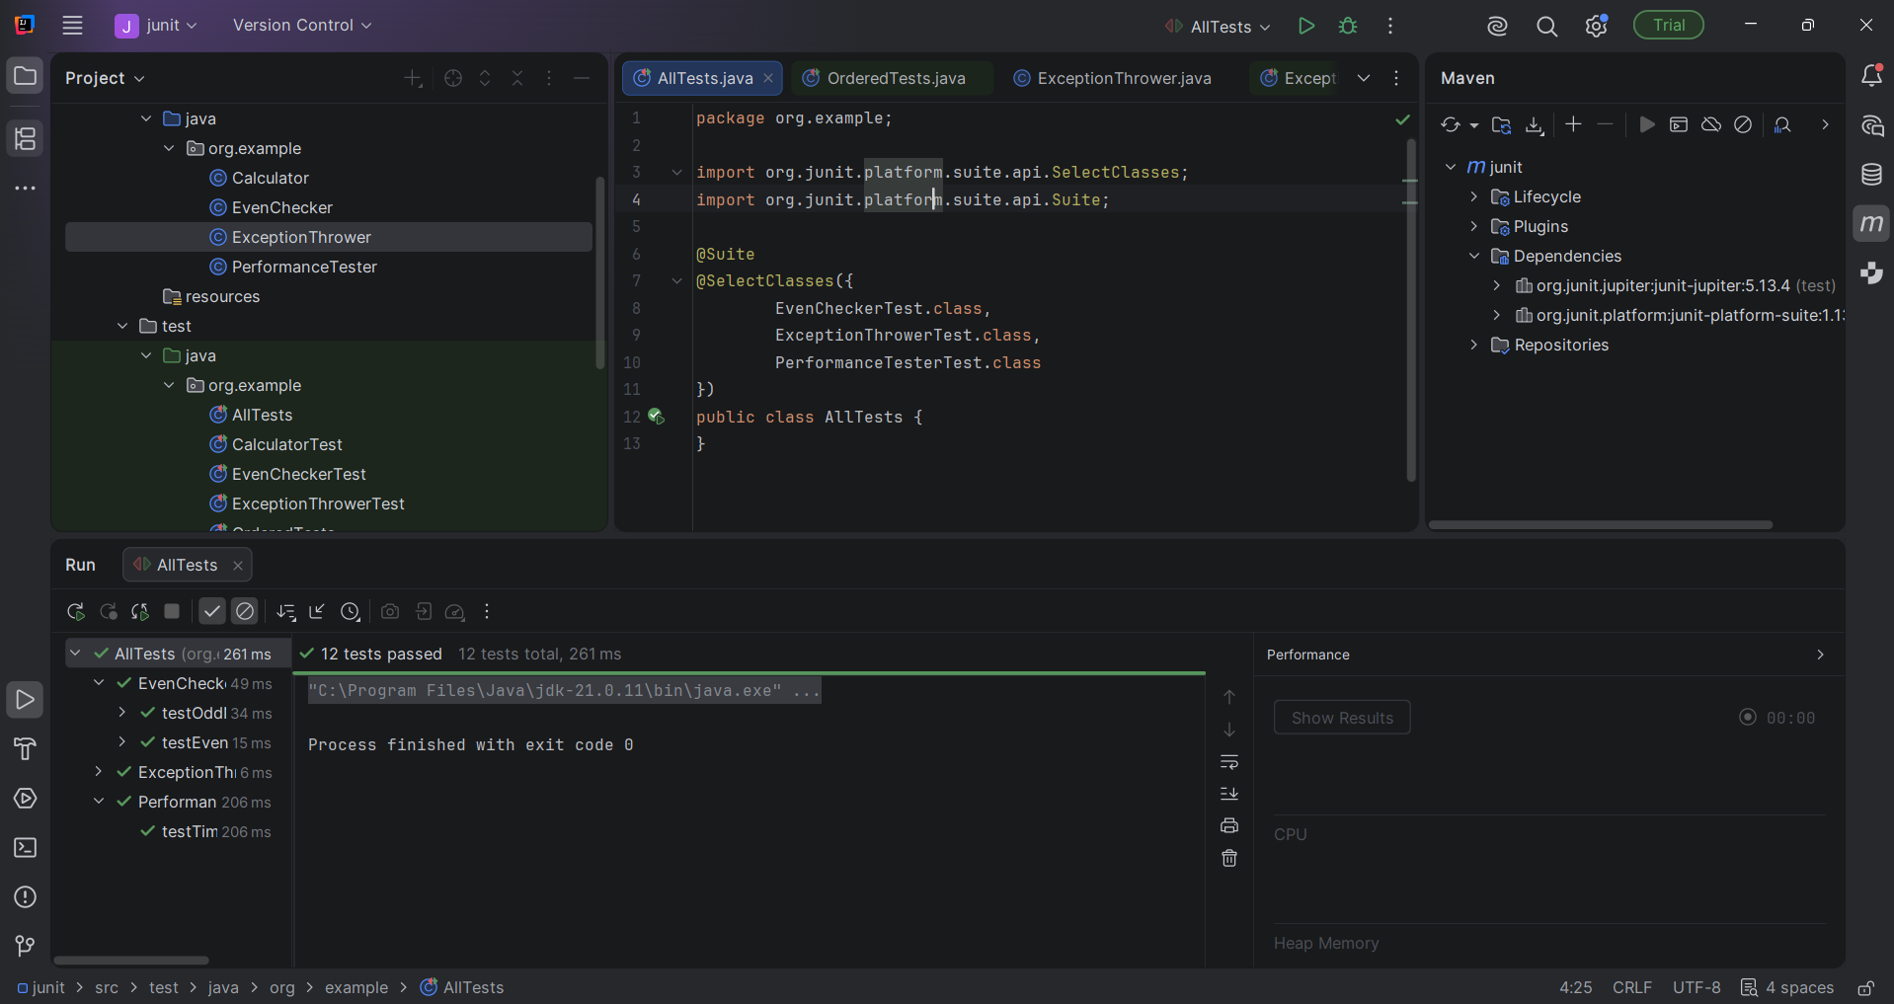

Exercise 3: Test Execution Order
OrderedTests.java
package org.example;
import org.junit.jupiter.api.*;
@TestMethodOrder(MethodOrderer.OrderAnnotation.class)
public class OrderedTests {
@Test
@Order(1)
void firstTest() {
System.out.println("First");
}
@Test
@Order(2)
void secondTest() {
System.out.println("Second");
}
@Test
@Order(3)
void thirdTest() {
System.out.println("Third");
}
}
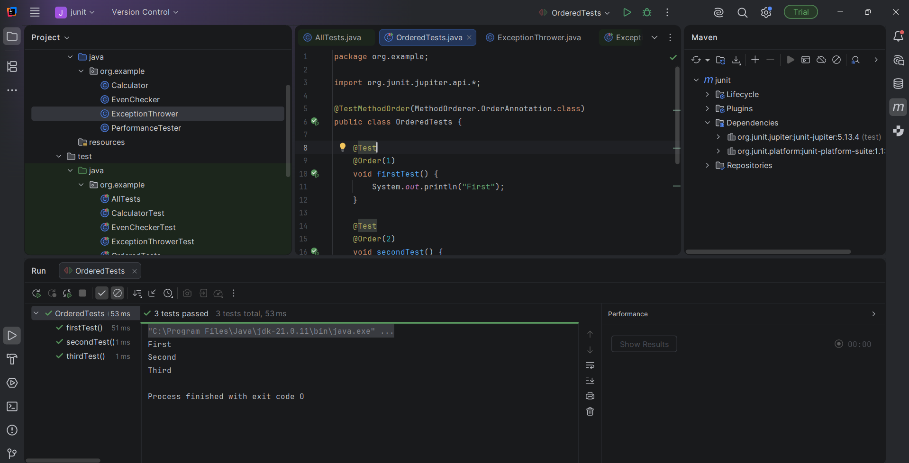

Exercise 4: Exception Testing
ExceptionThrower.java
package org.example;
public class ExceptionThrower {
public void throwException() {
throw new IllegalArgumentException("This is an exception");
}
}

ExcepionThrowerTest.java
package org.example;
import org.junit.jupiter.api.Test;
import static org.junit.jupiter.api.Assertions.*;
public class ExceptionThrowerTest {
@Test
void testExceptionThrown() {
ExceptionThrower obj = new ExceptionThrower();
assertThrows(IllegalArgumentException.class, obj::throwException);
}
}
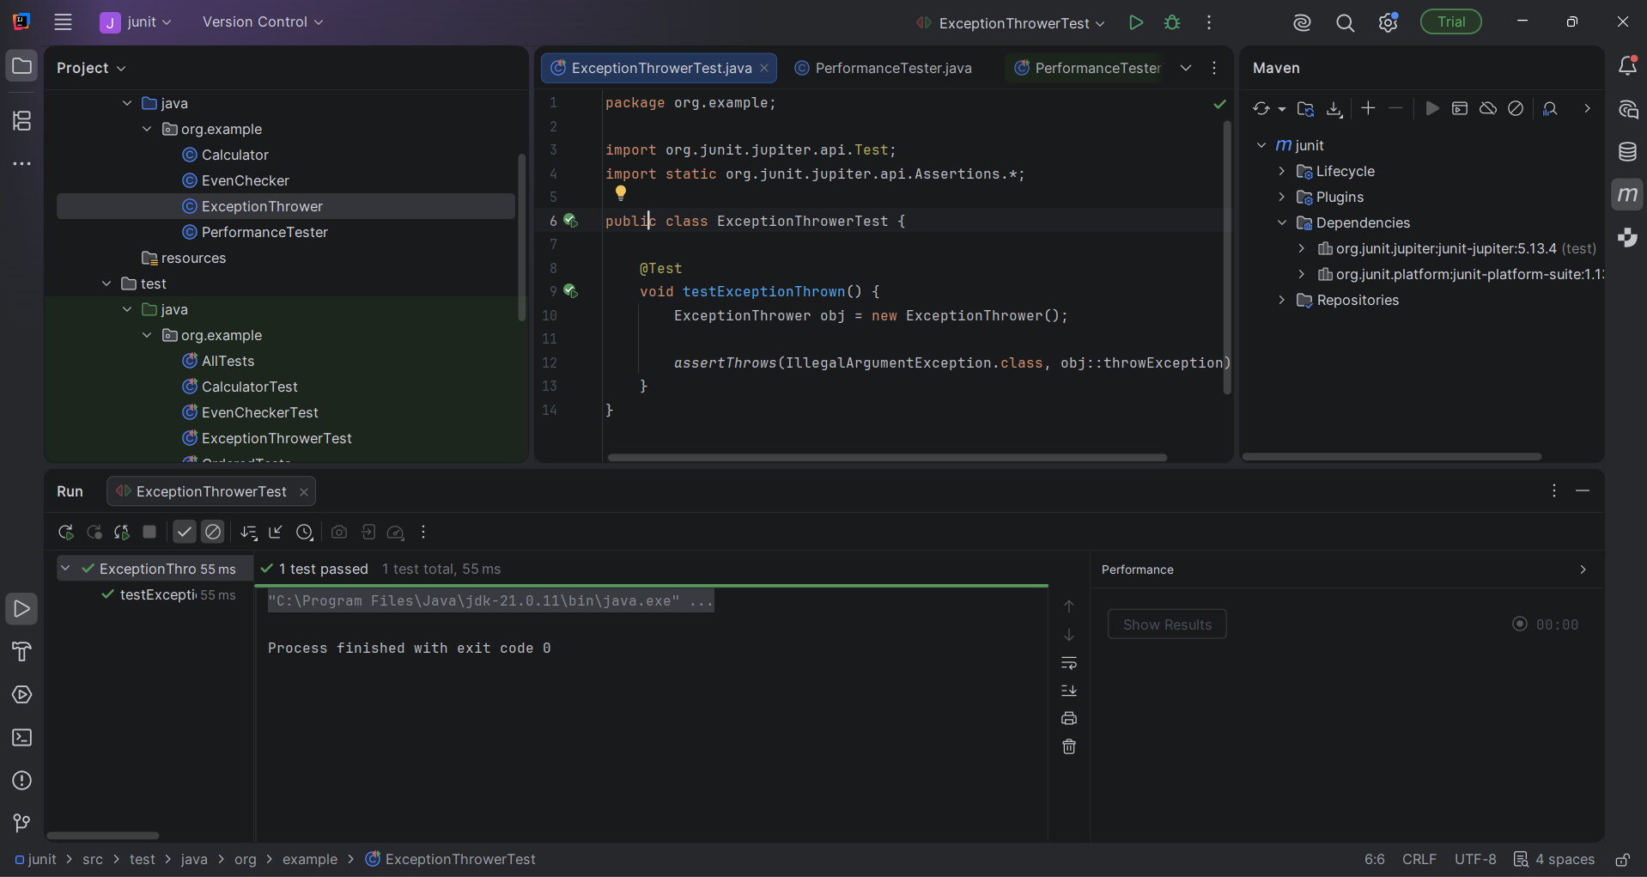

Exercise 5: Timeout and Performance Testing
PerformanceTester.java
package org.example;
public class PerformanceTester {
public void performTask() {
// simulate work
try {
Thread.sleep(200);
} catch (InterruptedException e) {
throw new RuntimeException(e);
}
}
}

PerformanceTesterTest.java
package org.example;
import org.junit.jupiter.api.Test;
import static org.junit.jupiter.api.Assertions.assertTimeout;
import java.time.Duration;
public class PerformanceTesterTest {
@Test
void testTimeout() {
PerformanceTester pt = new PerformanceTester();
assertTimeout(Duration.ofSeconds(1), pt::performTask);
}
}
